

LISTENING STUDY - HOW TO GET HERE
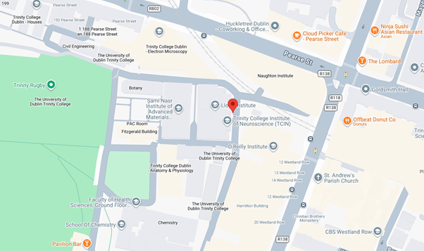
The study will be held at the Lloyd Institute, Trinity College Dublin.
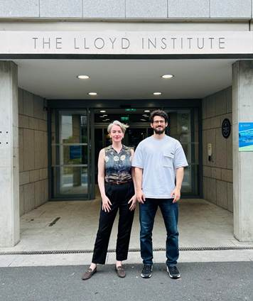
This is the Lloyd Institute entrance and some of our research team. When you arrive, come inside and wait for us in the lobby.

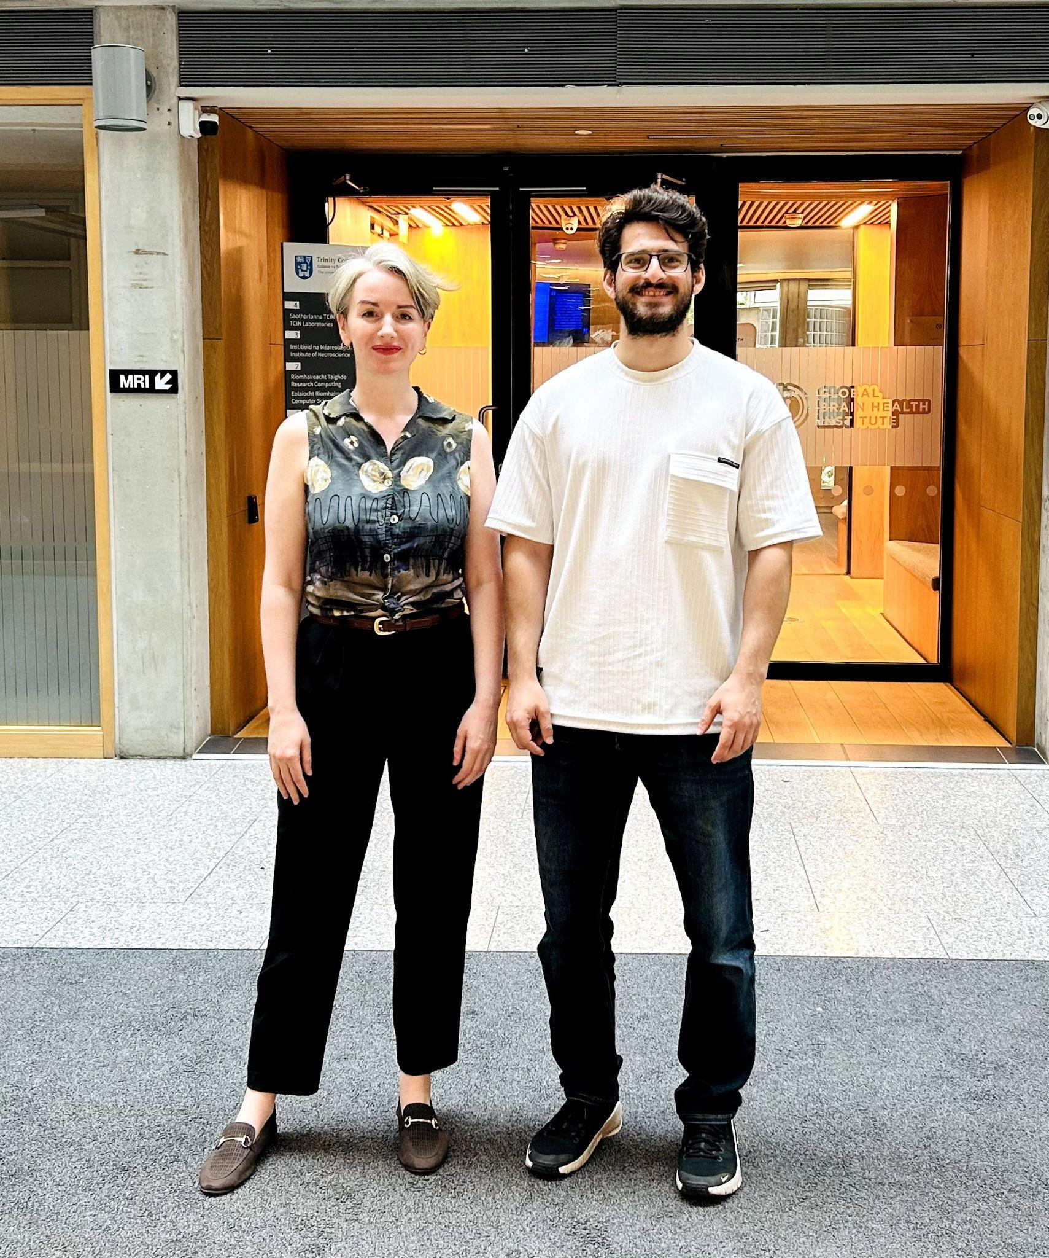
This is the lobby of the Lloyd Institute, where one of us will meet you. You do not need to find the room yourself. The photos below show what the walk to the room will look like.
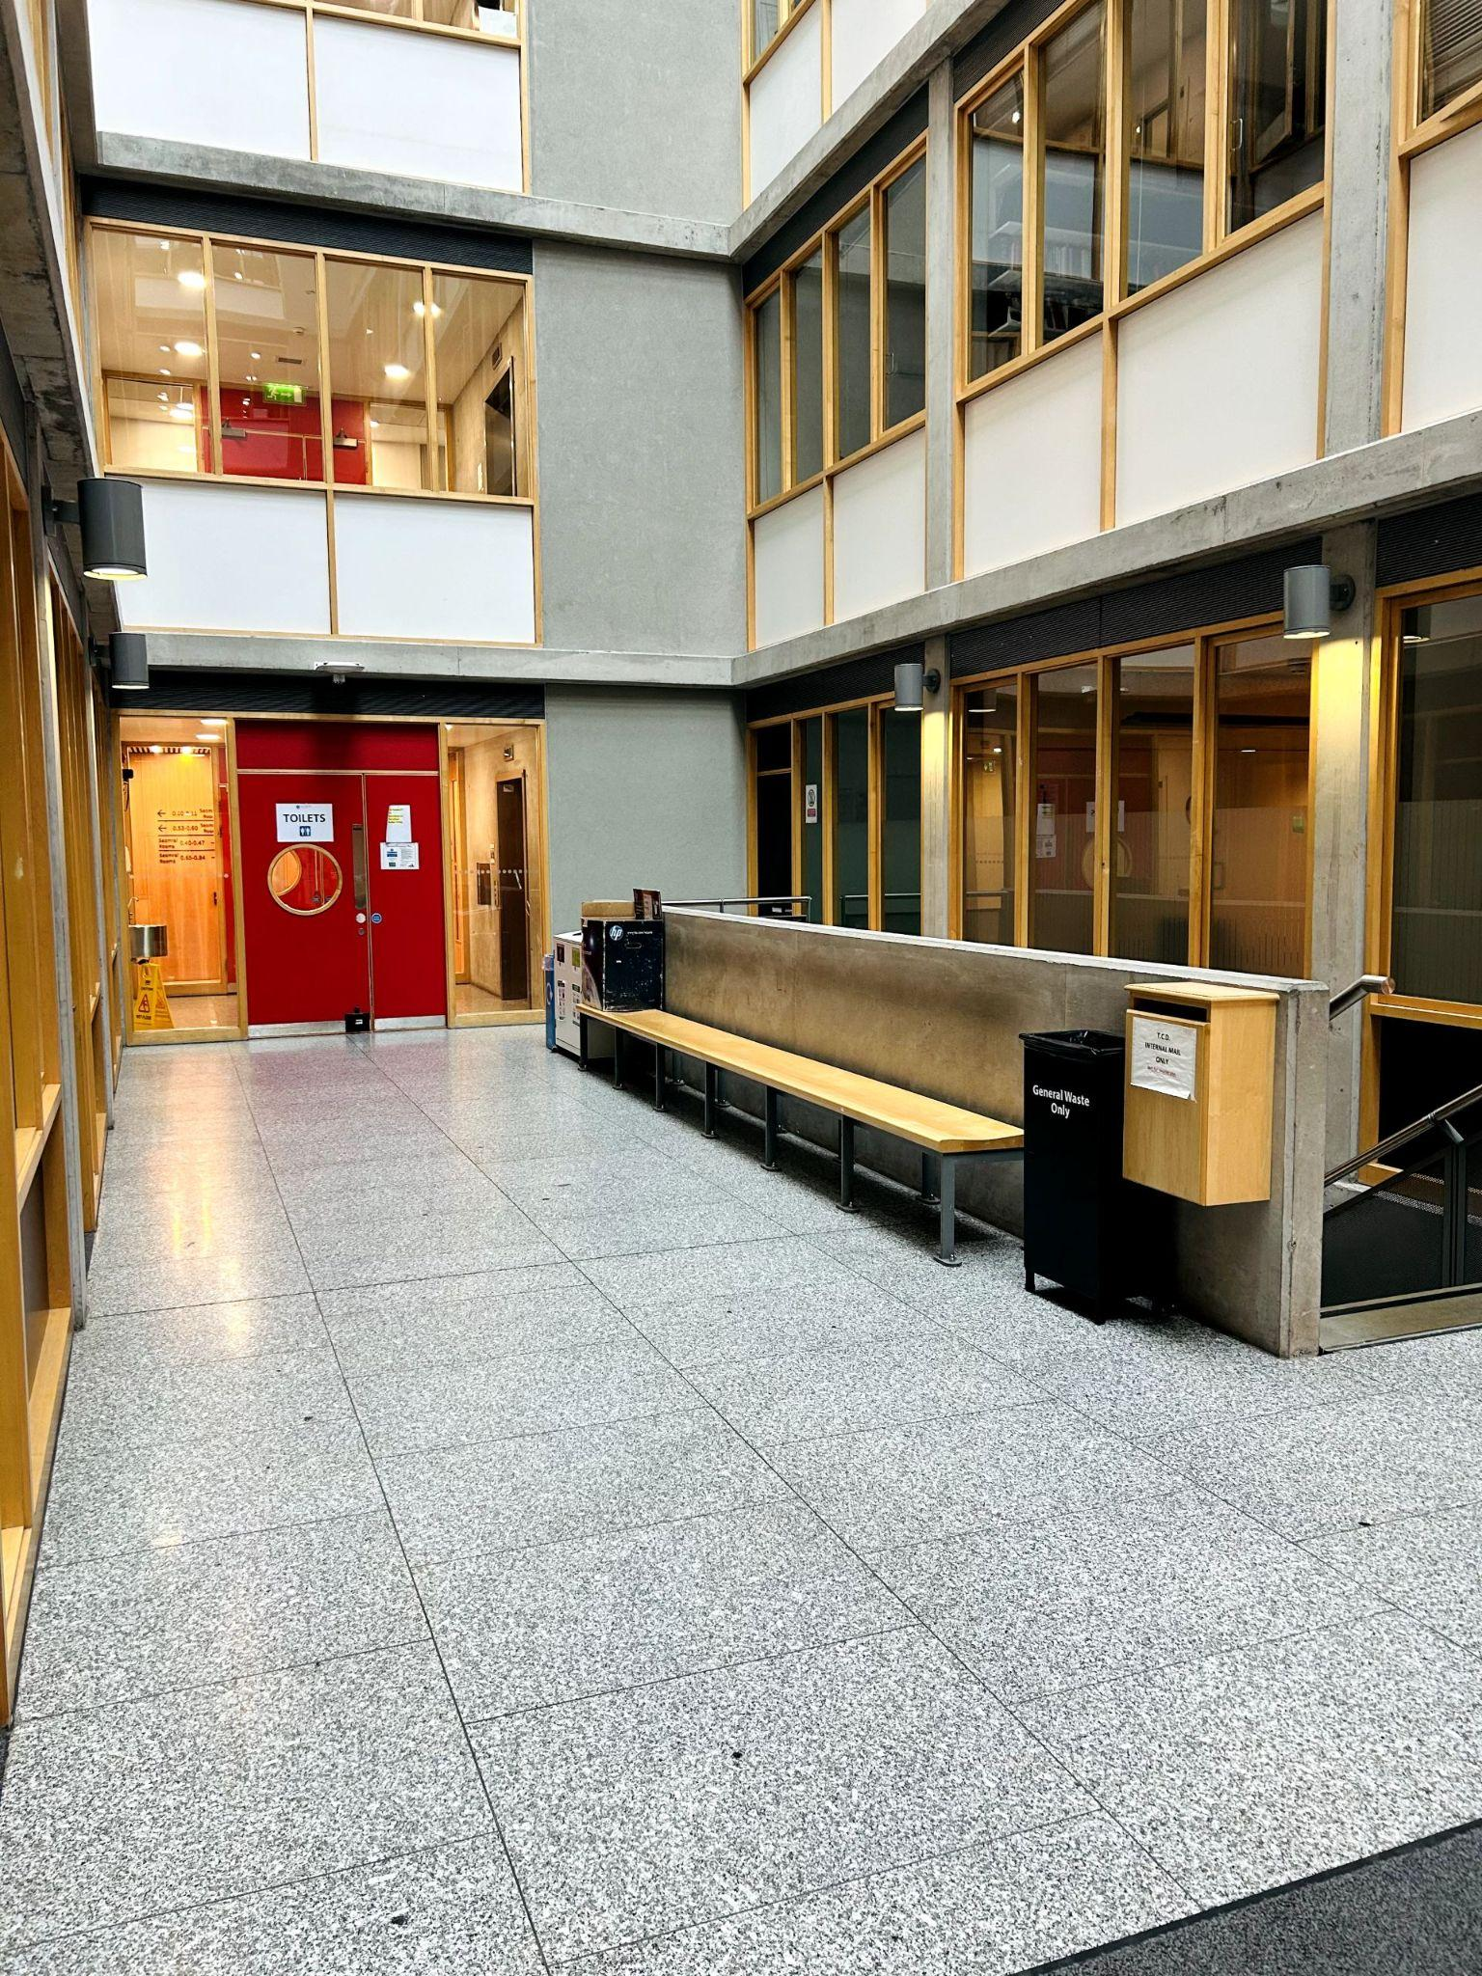
From the lobby, we will walk together through the red door.
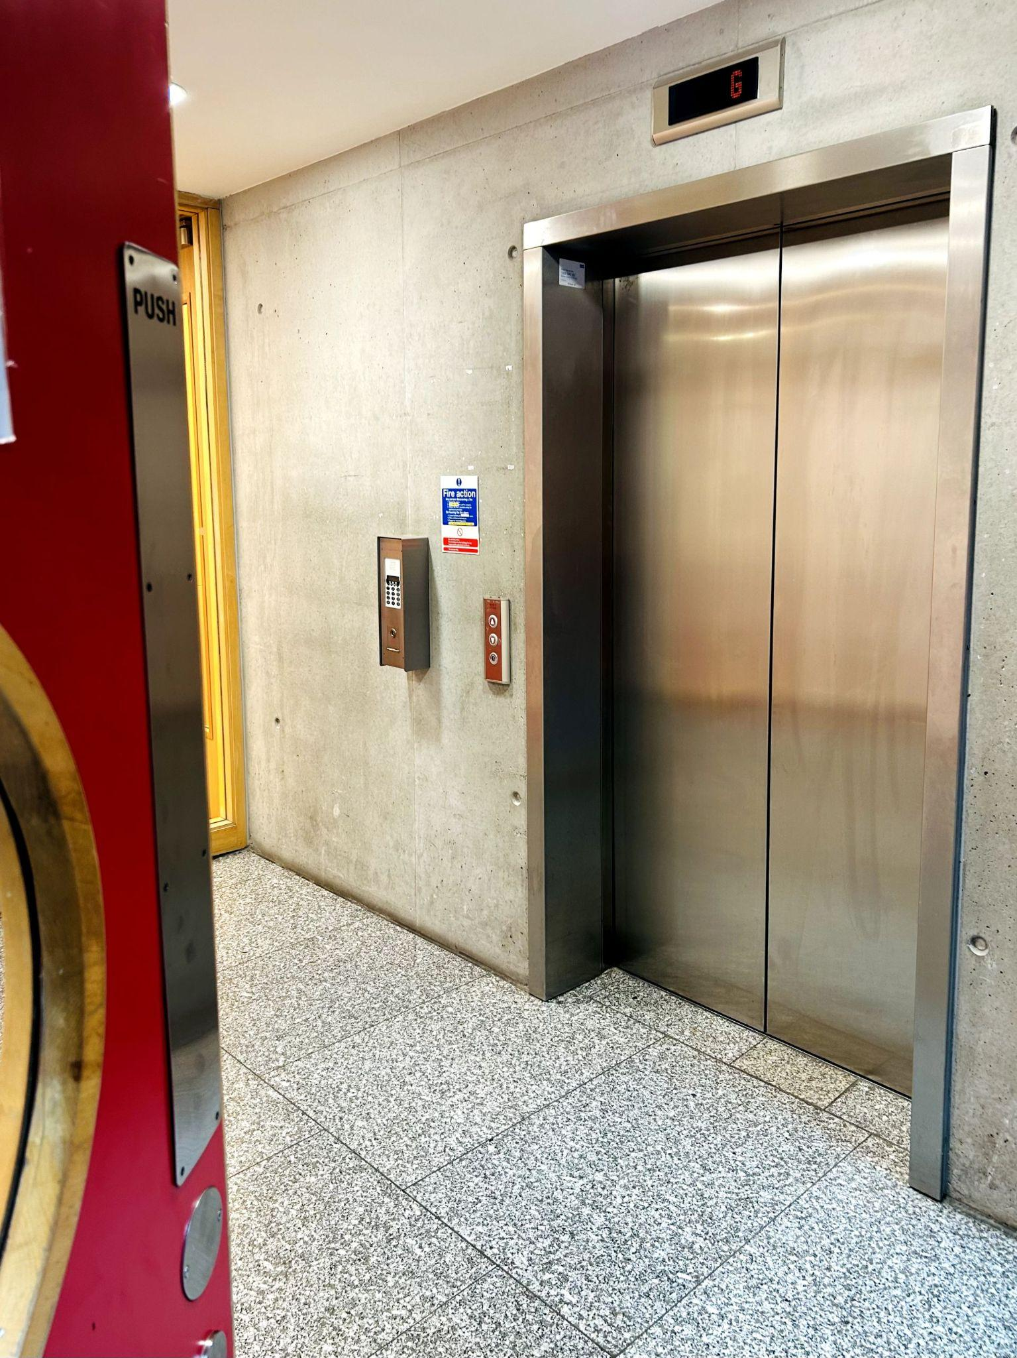
We’ll take the lift together to the 4th floor.
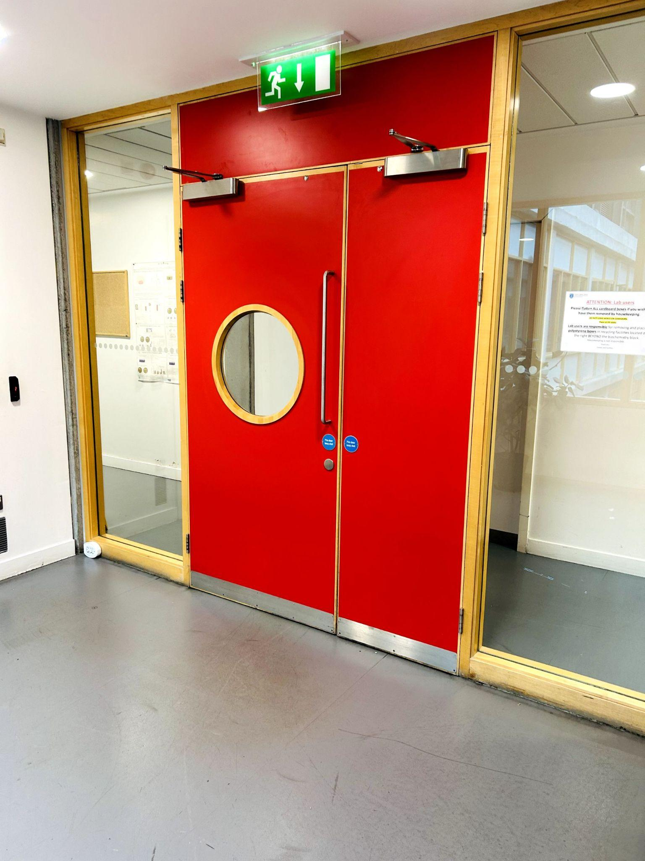
When we leave the lift, we’ll go through this red door.

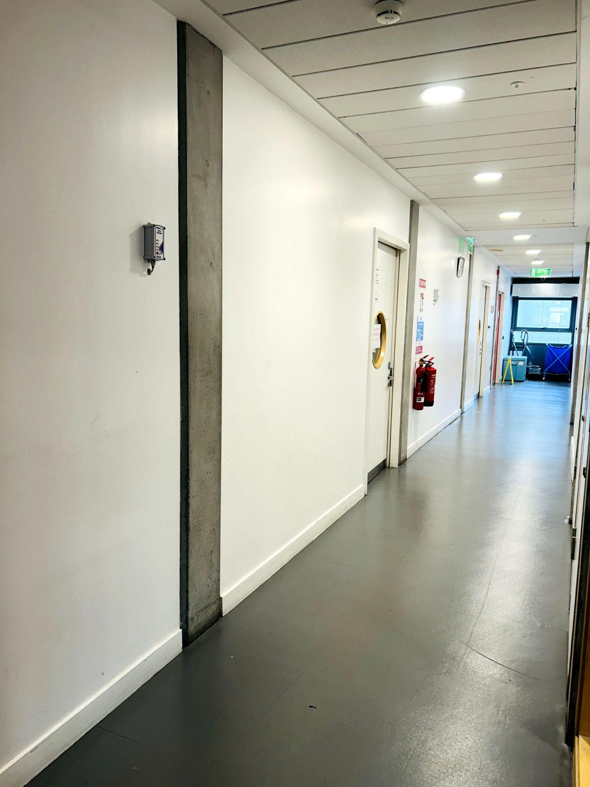
We’ll turn right here.

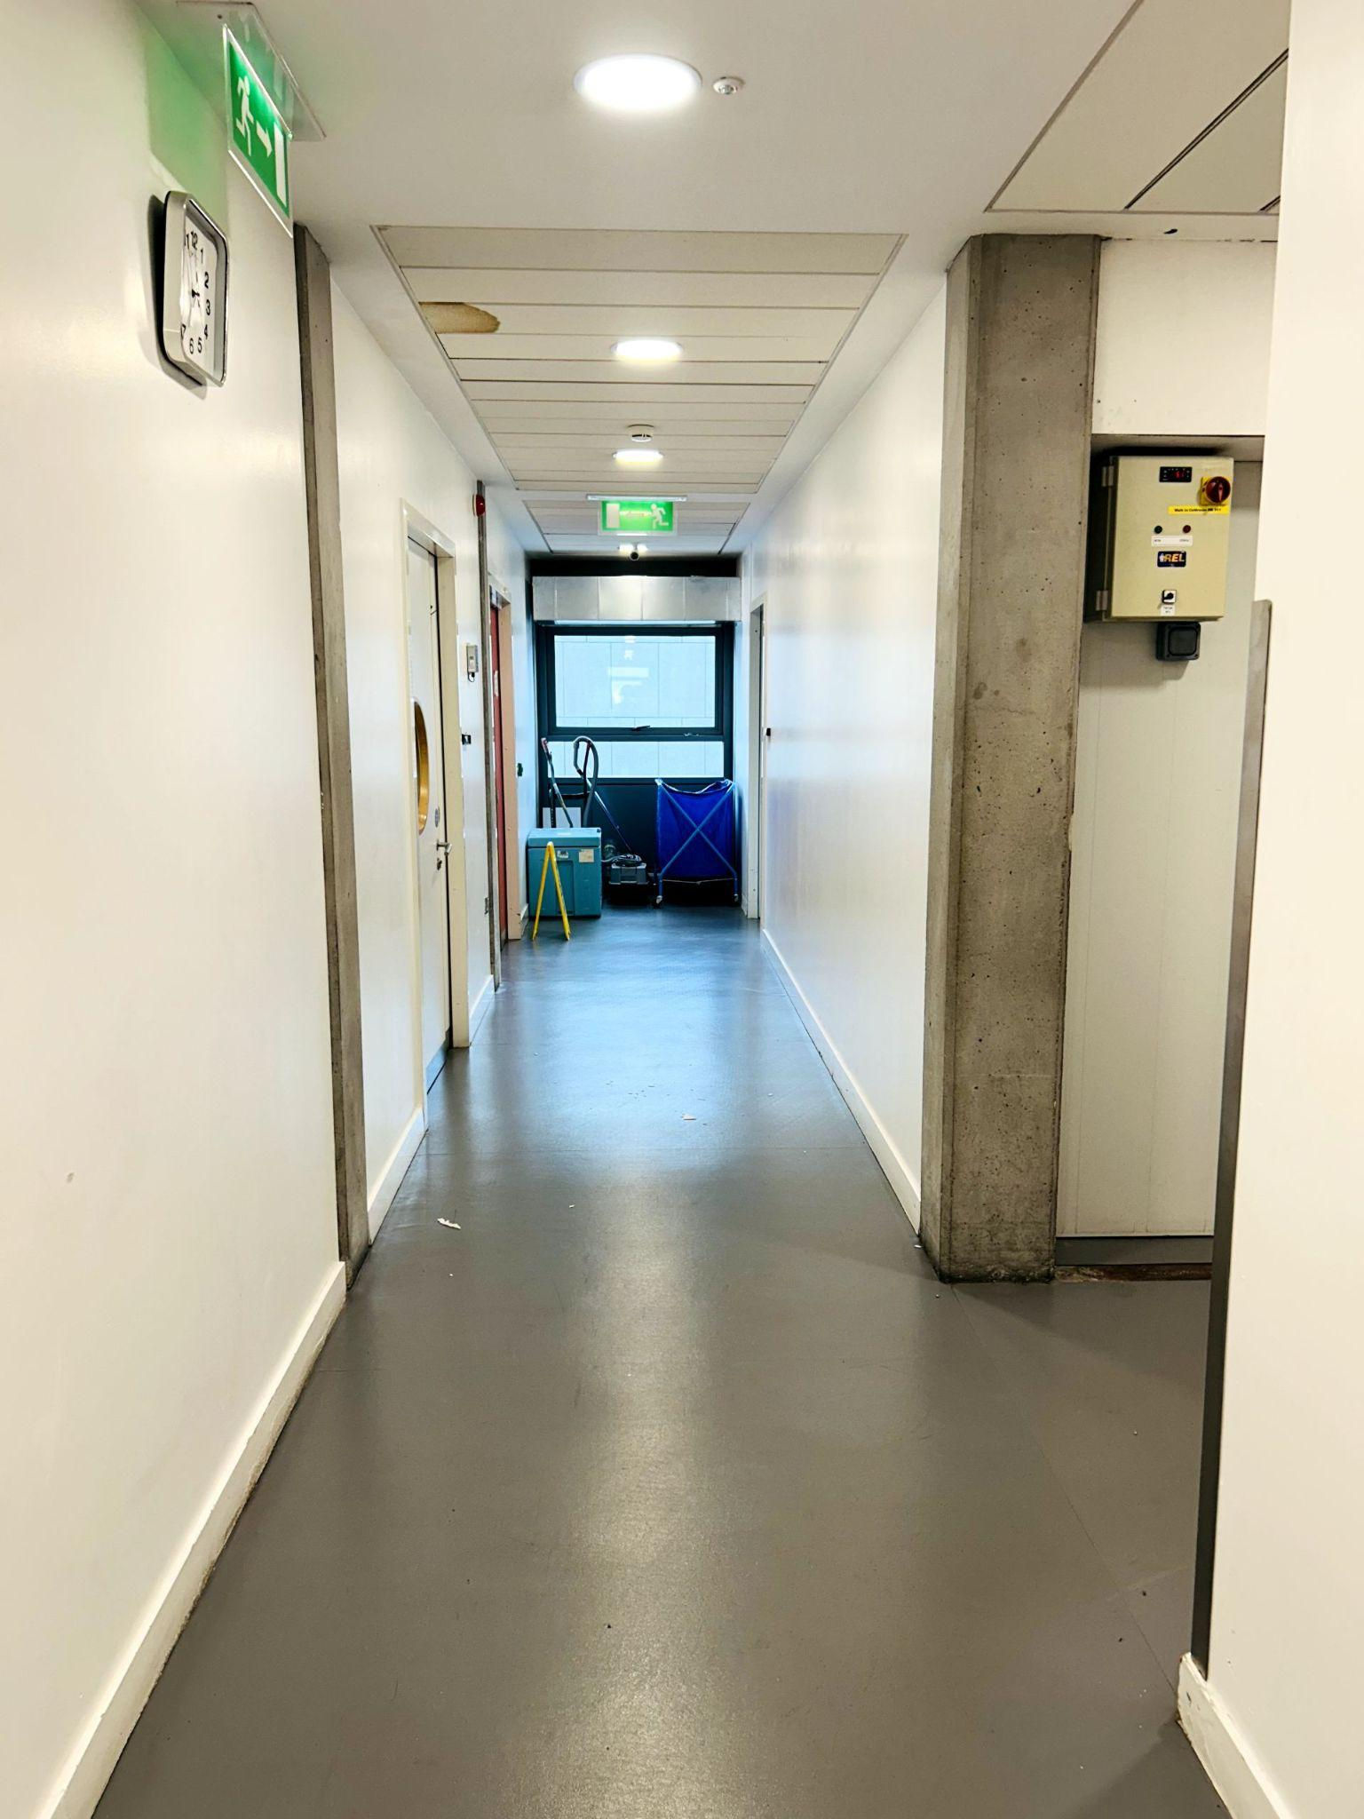
Then we’ll take the next right.

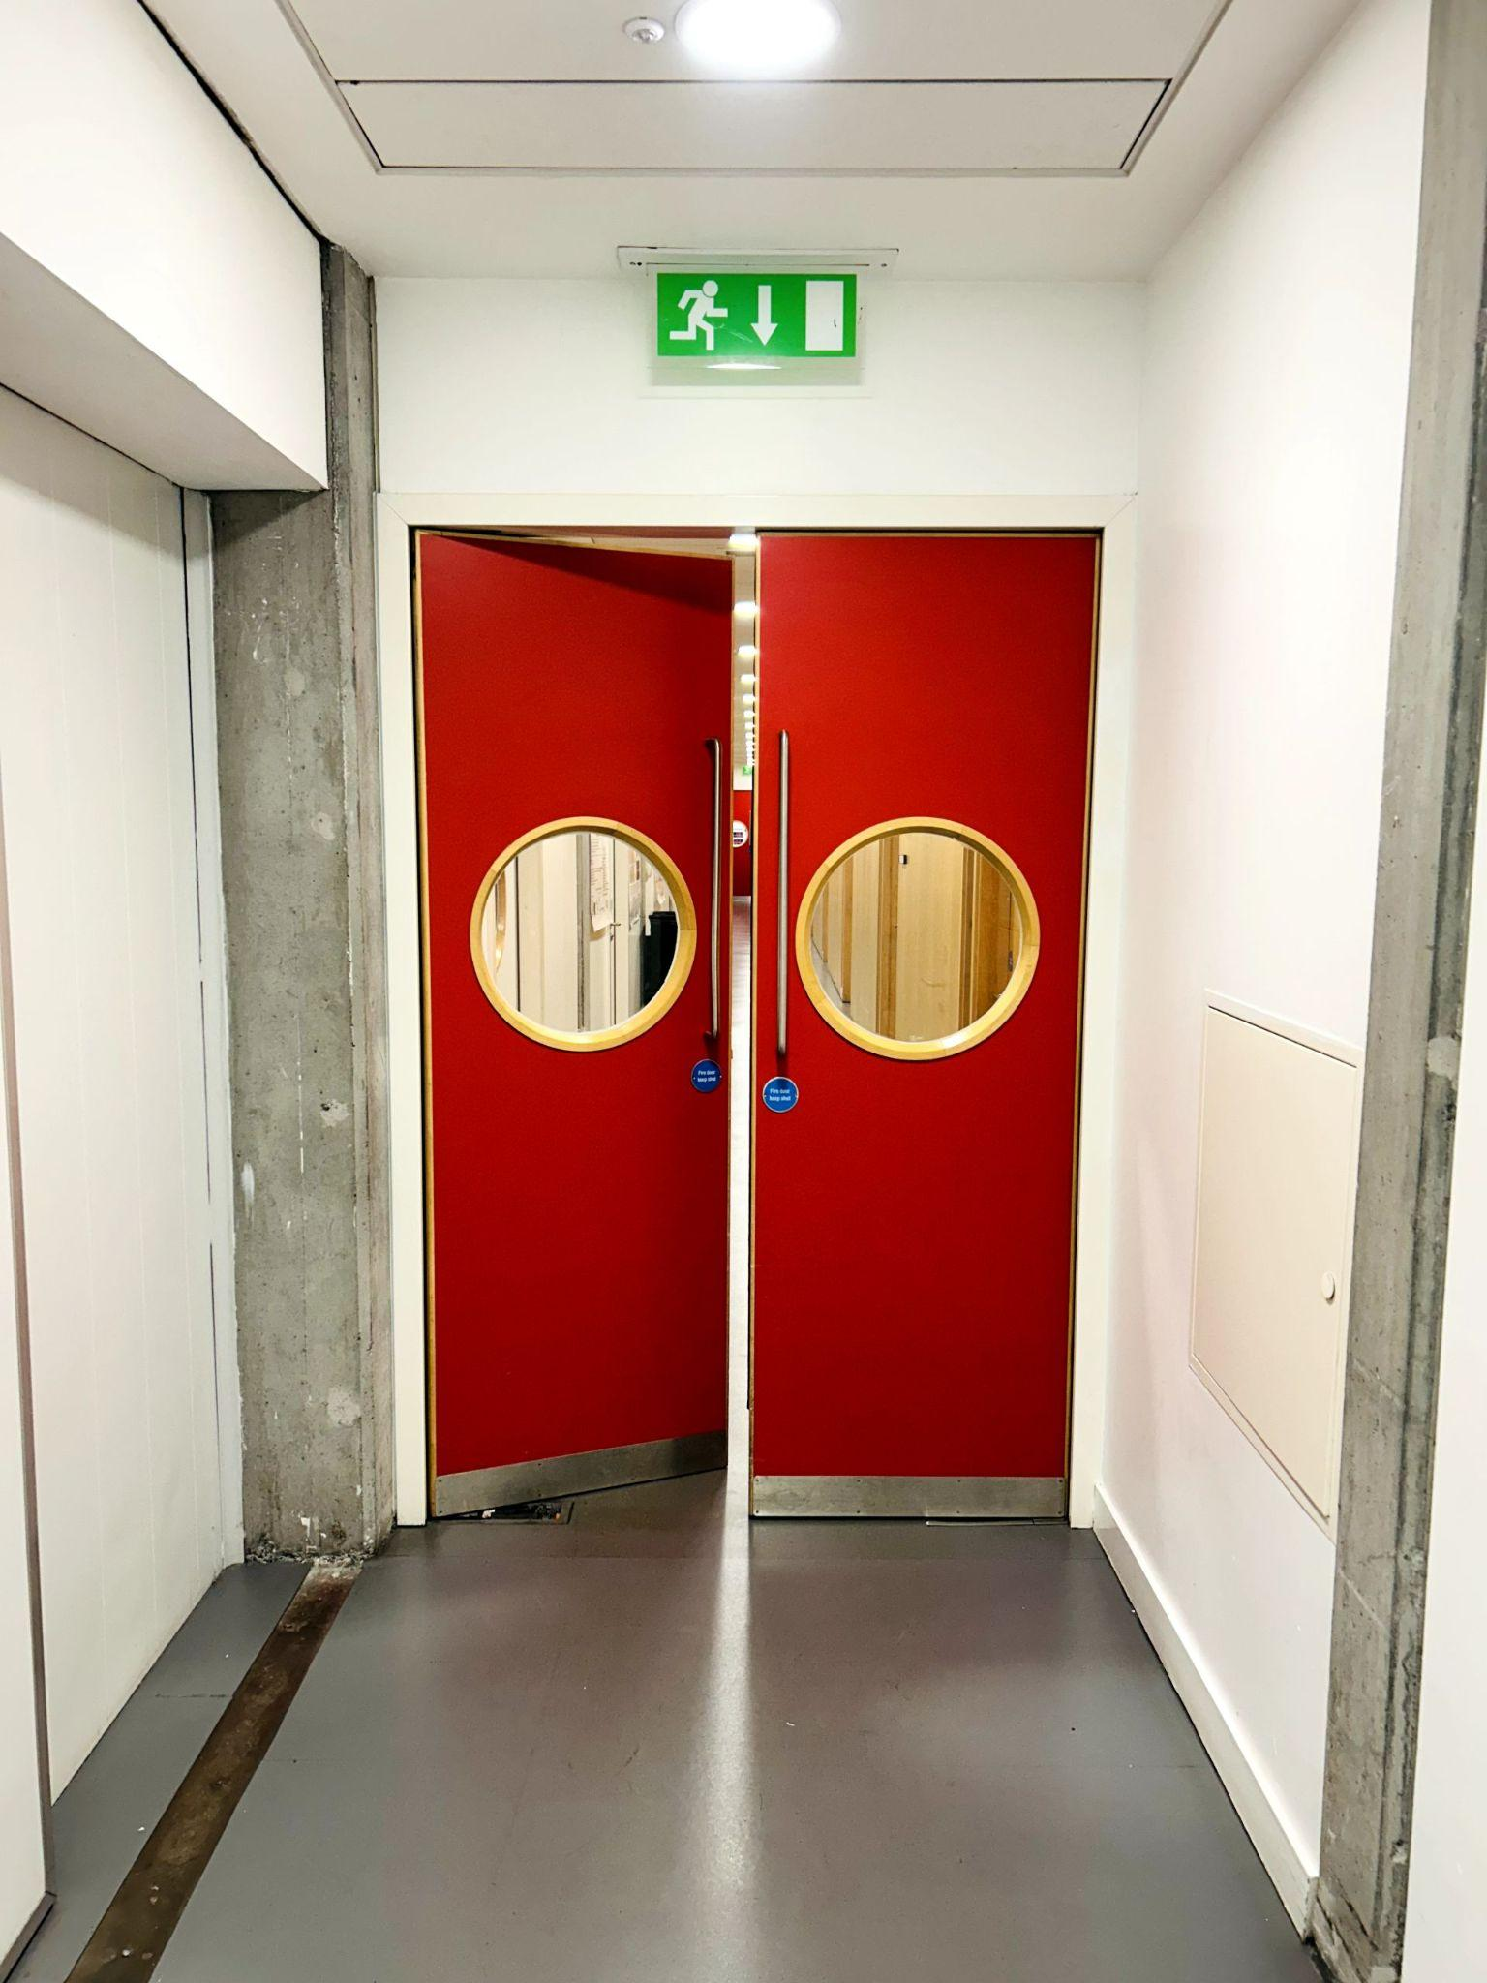
We’ll go through this red door.
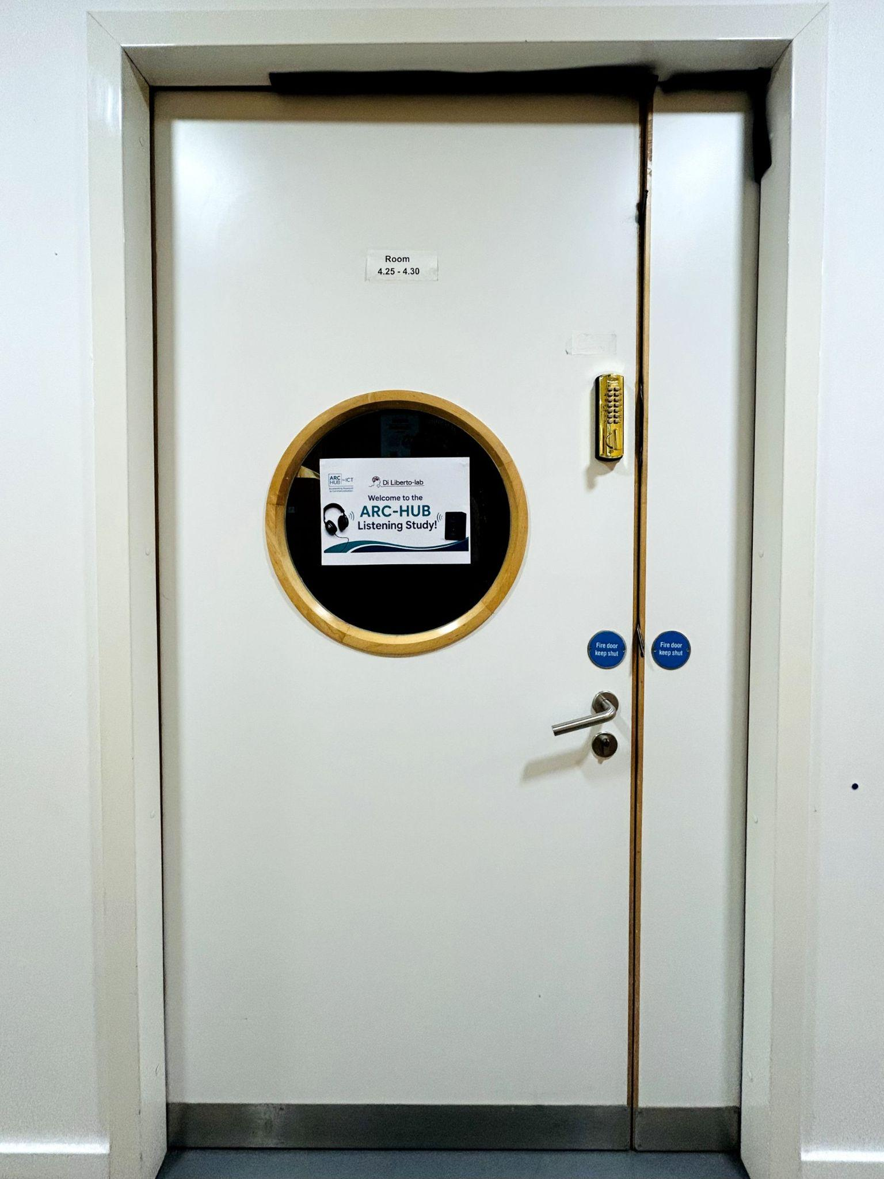
Then we will enter Room 4.25–4.30 on the left.
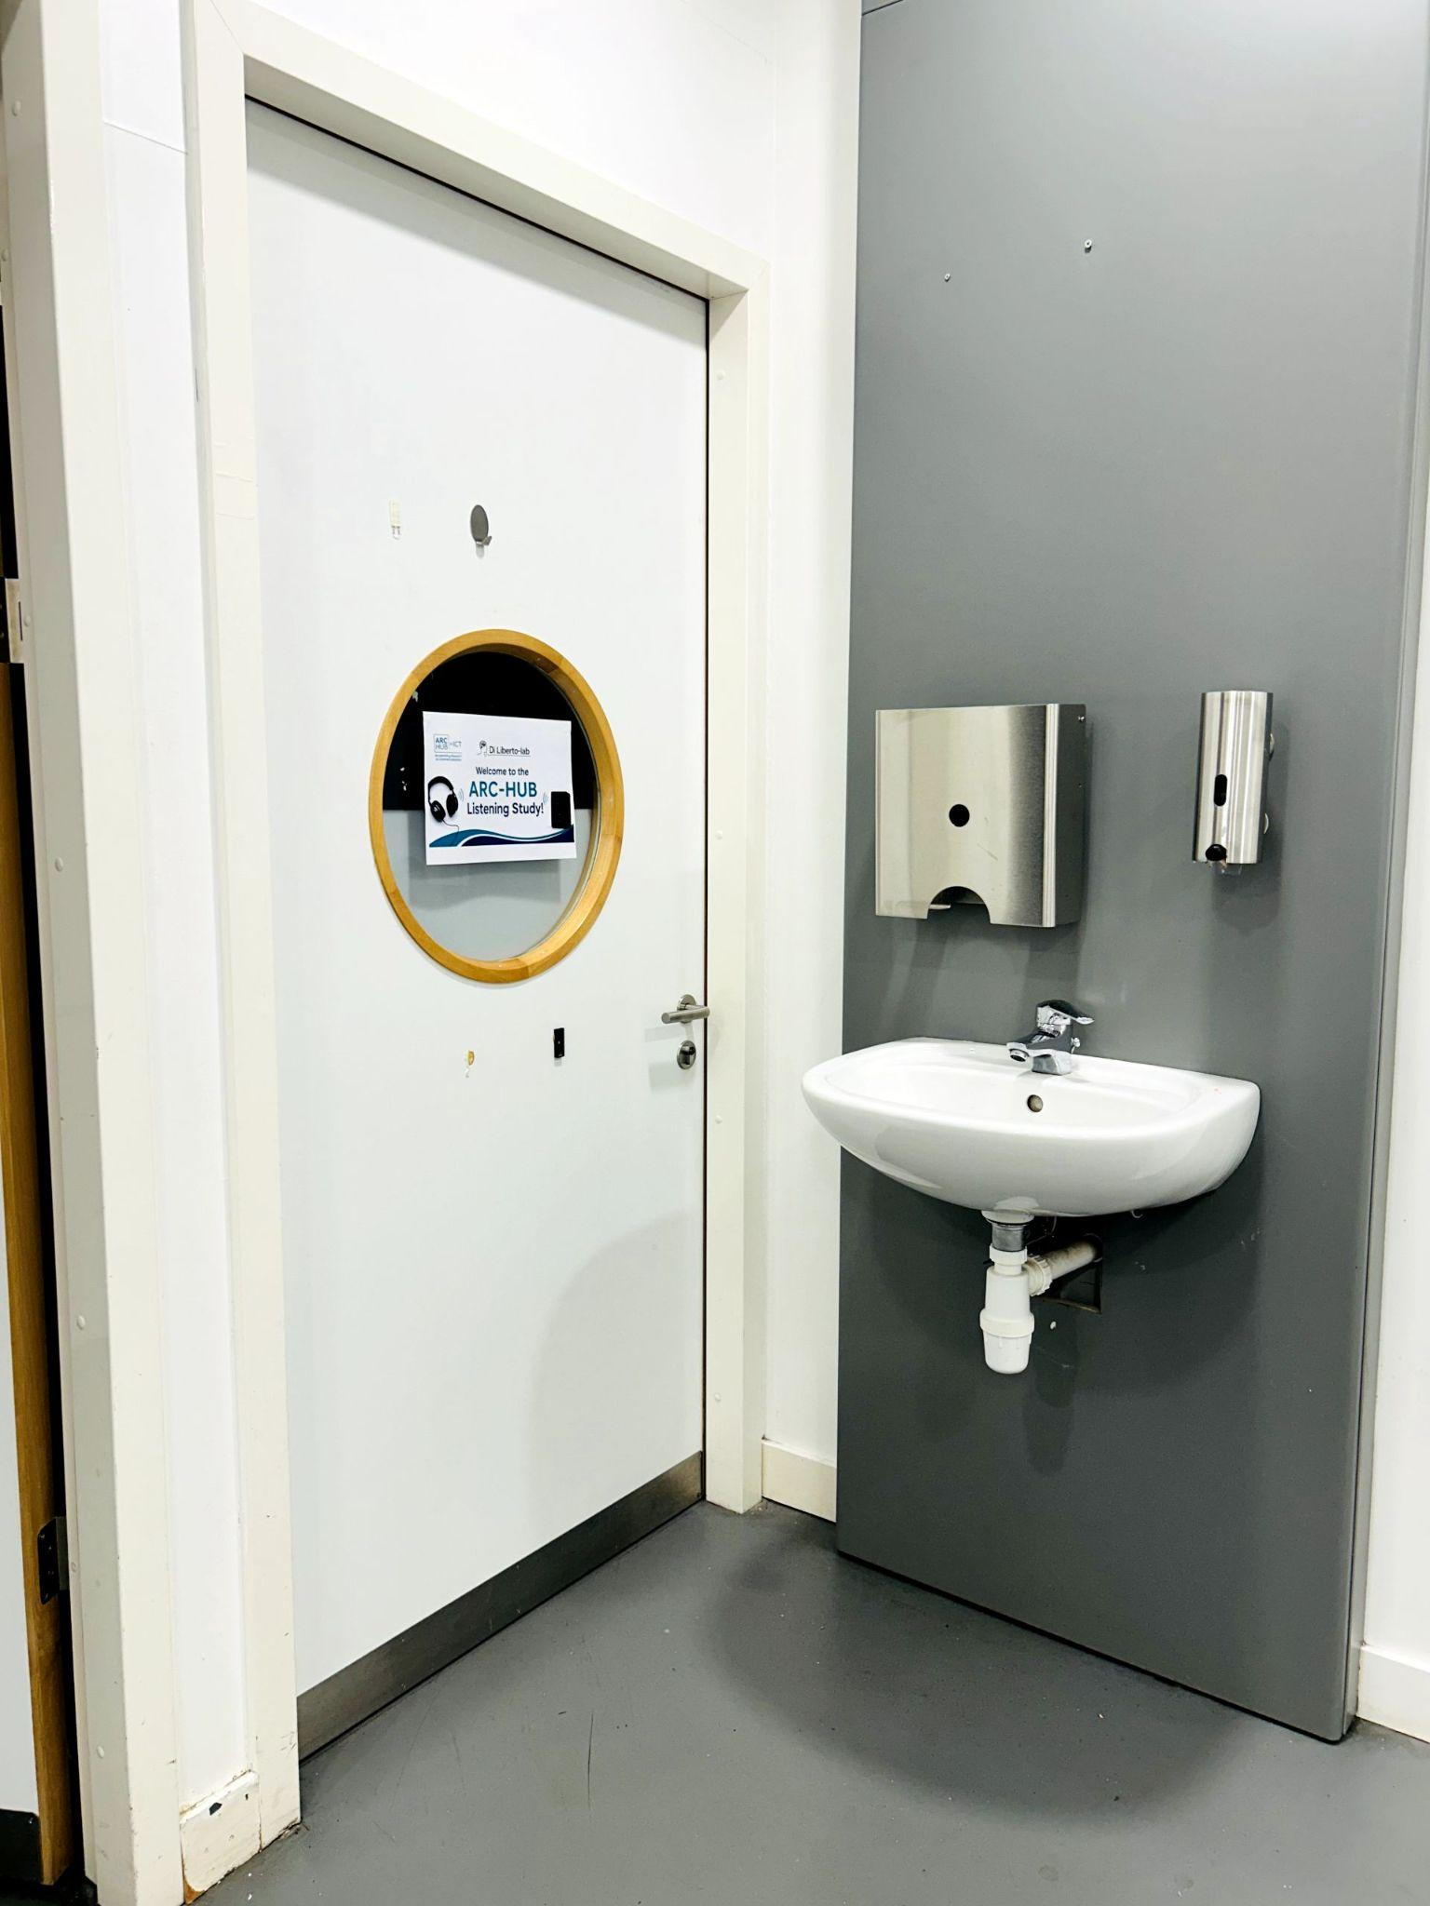
Our experiment room is the second room on the left, inside Room 4.25–4.30.
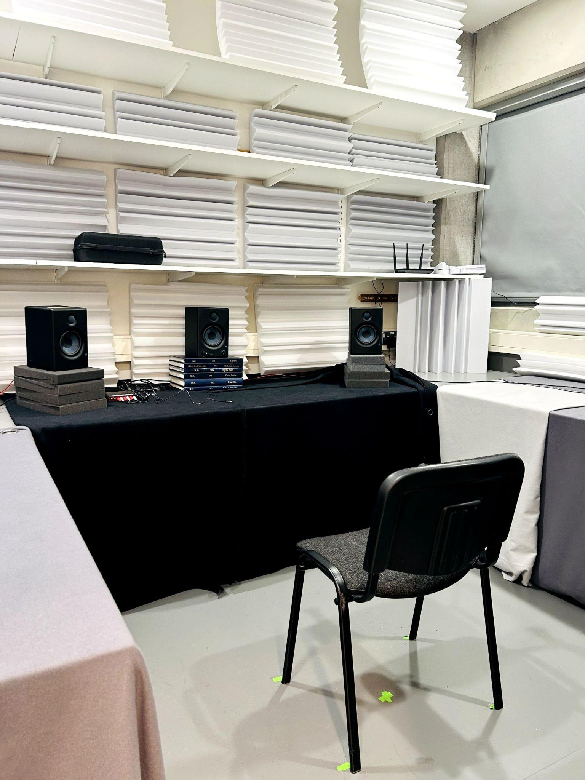
This is the experiment room where the listening study will take place!

